Participating in today’s service:

Elder of the Month: David Filer Deacon of the Month: Nancy Pearson
Music: Chancel Choir Reader: Alice Wood
Ushers/Greeters: Wendy Mott, Barbara D’Andrea, Dennis D’Andrea, Don Smith

Praying for healing, mourning, and peace
Liam Baum, Denise & Mike Chicca, Robert Fariel, Gordon Grant, Dana Lester, Gay Quarty, Jane Schmitz, Luca Sicuso, Jane Talmage, Jim & Susan Winkler, Kenny Eipel, Matt Herman, Kenny Luu, Nicholas Monokrousos, Jim Falacara, the family of Dr. Edwards’ father, and Our Sister Church in Guines, Cuba, their pastor and his family, and our pastor nominating committee.

EAST HAMPTON FOOD PANTRY serves our community by collecting food and
distributing it to those in need. This week’s item of the week is hot or cold cereal.
CALENDAR
Sunday 10:00 am Sunday Worship
4:30 pm Springs Porch Musicians in Session House
Monday: 9:00 am Prayer Group in the Session House
12:30 pm Al-Anon in Session House
Tuesday: 7:30 am Men’s Breakfast at John Papa’s
1:00 pm Prayer Shawl Knitting at Mary Siska’s
Thursday: 12:30 pm Al-Anon in Session House
3:30 pm Choir Rehearsal
Sunday: 10:00 am Sunday Worship
4:30 pm Springs Porch Musicians in Session House

Please let the church office know if you need to park your car overnight on the church grounds.

www.fpceh.org

First Presbyterian Church of East Hampton

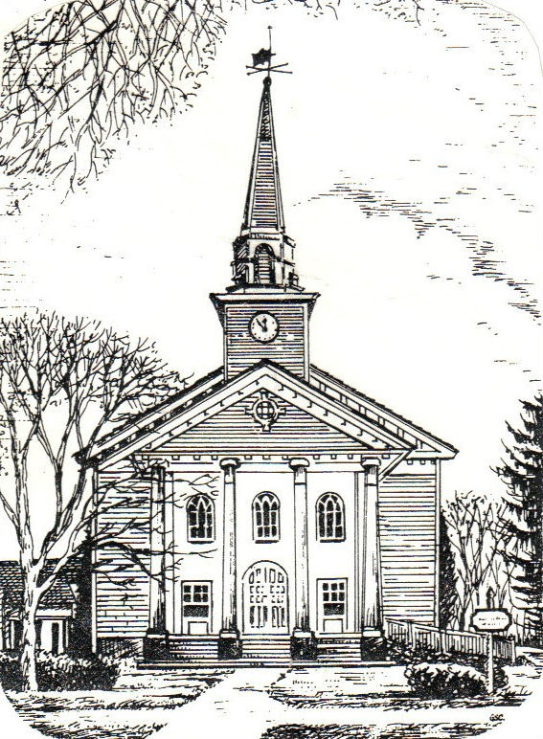

Celebration of the Lord’s Day
April 16, 2023 – 10:00 a.m. The Resurrection of the Lord ______________________________________________________________________

WELCOME
Whether today is your first time worshipping with us or you are from one of our founding families, we
are glad you are here! The First Presbyterian Church of East Hampton is an open and affirming
community, always looking for new ways to embody Jesus’ call to love God and our neighbors
in this community and throughout the world. We’d love for you to be part of our future,
continuing Jesus Christ’s earthly ministry of building God’s Kingdom.

We’d Love to Hear from You!

Elder Kristy LaMonda, Guest Speaker

Jane Hastay, Music Director
(631) 332-2550 – musicdirector@fpceh.org

June Lester, Church Administrator
(631) 324-0711 – fpcsecy@optonline.net
Office Hours: Weekdays (closed Monday), 9:00 – 1:00

120 Main Street; East Hampton, NY 11937

Pastors Emeriti
The Rev. Dr. John Ames The Rev. Dr. Fred Schulz

Gathering in God’s Name
As we gather, take time quietly to sit and prepare your heart to worship God
Prelude
Welcome and Announcements
*Call to Worship
Leader: Alleluia! Christ is risen!
People: Our hearts are glad and our souls rejoice.
Leader: Do not worry or fear, for Christ is alive!
People: In this place, we find hope and joy.
Leader: Alleluia! Christ is risen!
People: Let us worship the one who brings new life.

*Opening Prayer
Life giving God, we gather today to celebrate the resurrection of your Son. We are grateful for the new life he brings. We are grateful for the hope and joy he shares. We are grateful for leading the way, as he goes before us. Gracious God, today and every day, we offer you our thanks and praise. Strengthen our faith, that it may sustain us during difficult days and enable us to share your love with others. Open our hearts to new life and possibilities. In the name of Christ, we pray. Amen.
*Hymn #246 “Christ Is Alive!” Musica Sacra, c 1778

Prayer of Confession (unison)
God of mercy and grace, you understand us completely. Yet there are times when we do not understand this life of faith. We do not understand how Jesus rose from the dead. We do not understand how the resurrected Christ comes to us today. Moments of doubt and disbelief sap our strength. Forgive and restore us. Help us trust you and your love for us. And help us trust the ways of Christ. Amen.

Assurance of Pardon
Leader: The One who loves us and frees us will not leave us in despair and doubt, but will fill us with joy and conviction.
People: Let us praise and witness to the Holy One – the one who says I am the Alpha and Omega, the beginning and the end; the one who is with us always. Amen.

*Passing of the Peace

*Gloria (Hymn 582) Glory to God, Whose Goodness Shines on Me Paul M. Vasile
Glory to God, whose goodness shines on me, and to the Son, whose grace has pardoned me, and to the Spirit, whose love has set me free. As it was in the beginning, is now and ever shall be, Amen. World without end, without end. Amen. As it was in the beginning,
is now and ever shall be. Amen.

Proclaiming God’s Word
Children’s Message
Prayer for Illumination
Scripture Readings: Acts 2:14a, 22 - 32 NT page 119
John 20: 19 - 31 NT page 114
Sermon “Necessary Doubt” Elder Kristy LaMonda

Responding to God with Thanksgiving

*Hymn #494 “Jesus, Thou Joy of Loving Hearts!” Henry Baker
*Affirmation of Faith The Apostles Creed page 35 in hymnal
Prayers of the People and the Lord’s Prayer

Invitation to the Offering
Through the resurrection of Christ, we have been given new birth and a living hope. In thanksgiving and praise, let us bring gifts to God.
Offertory
*Doxology (Hymn 606) “Praise God, from Whom All Blessings Flow” Genevan Psalter
Praise God, from whom all blessings flow; Praise God, all creatures here below;
Praise God above, ye heavenly host; Praise Father, Son, and Holy Ghost. Amen

*Prayer of Dedication
Holy one, bless our offerings and transform them into healing for the wounded, hope for the disheartened, courage for the frightened, and faith for the embittered. In the name of Jesus Christ, your faithful witness, the first resurrected, and ruler of the sovereigns of the earth. Amen.
*Hymn #634 “To God Be The Glory” William Howard Doanne
*Charge and Benediction
Postlude

